Steps to follow while creating Web Api Project

1. Open Visual Studio

2. File New Project

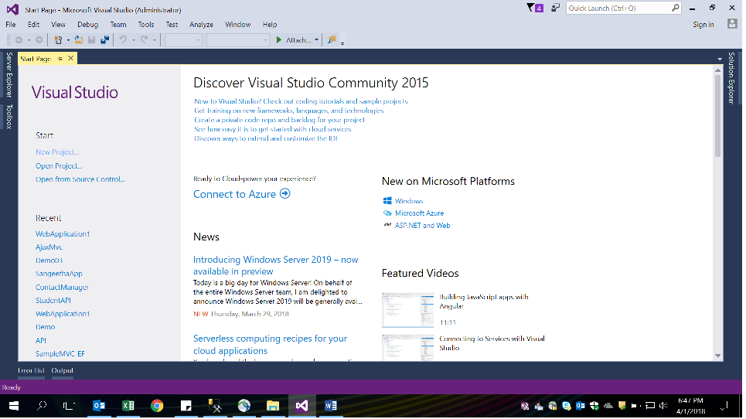

3. Select Web Template

4. In that ASP.NET Web Application

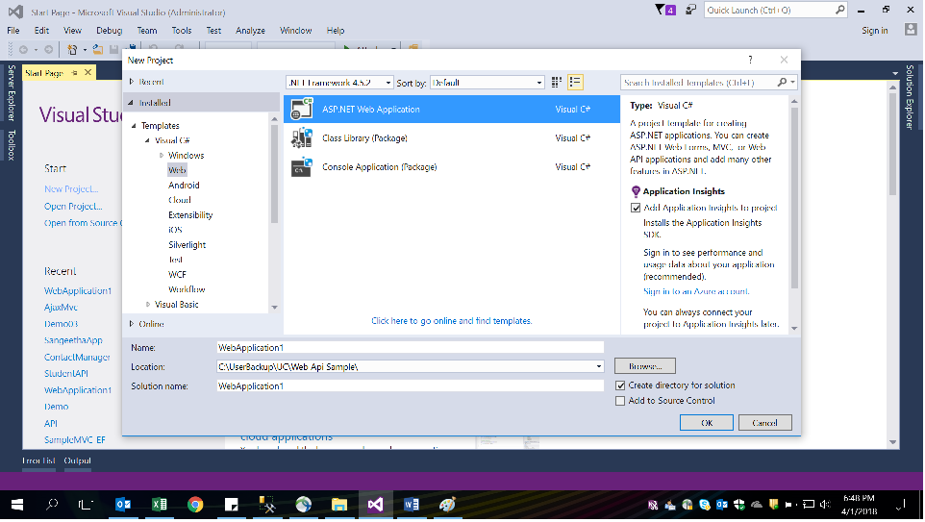

5. In the ASP.NET 4.5.2 Template select Web Api

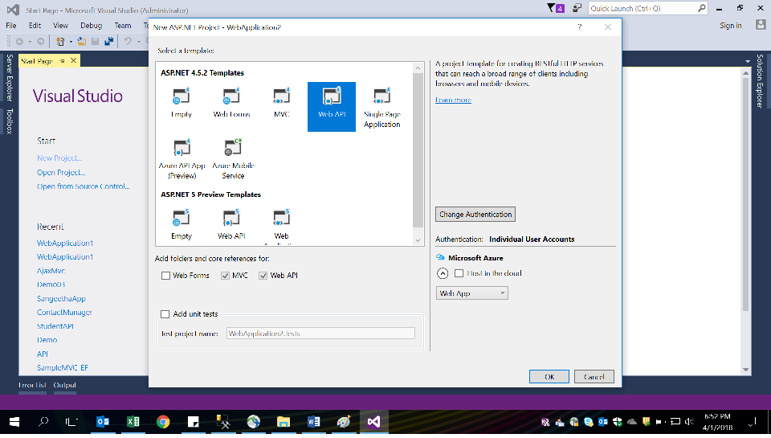

6. In the Models folder add EF Data Model

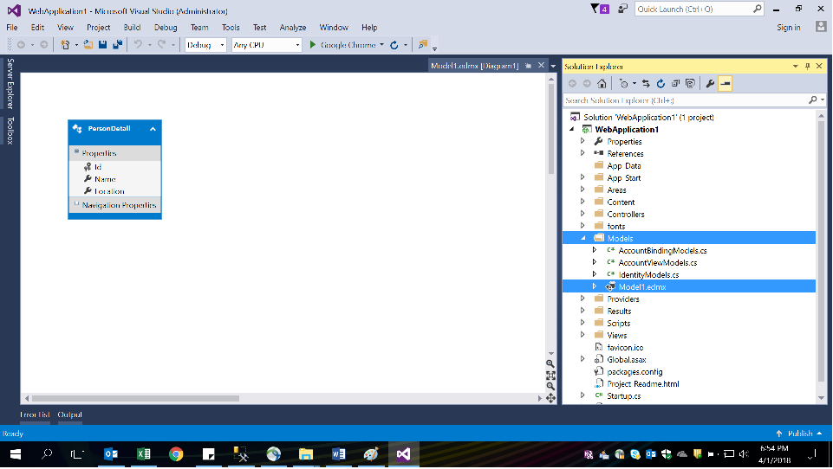

7. In the Controllers folder add a new Controller Class and Implement the Get, Post, Put and Delete methods. This would be your Web API Controller class.

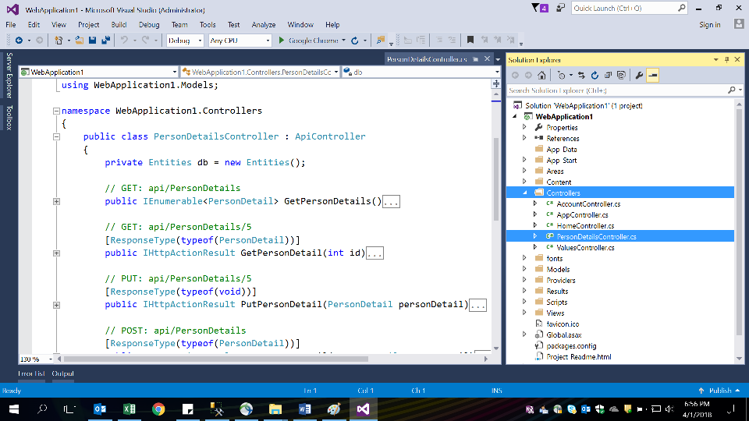

8. Next Add one more Controller Class to the Controller folder. This would be your MVC Application controller.

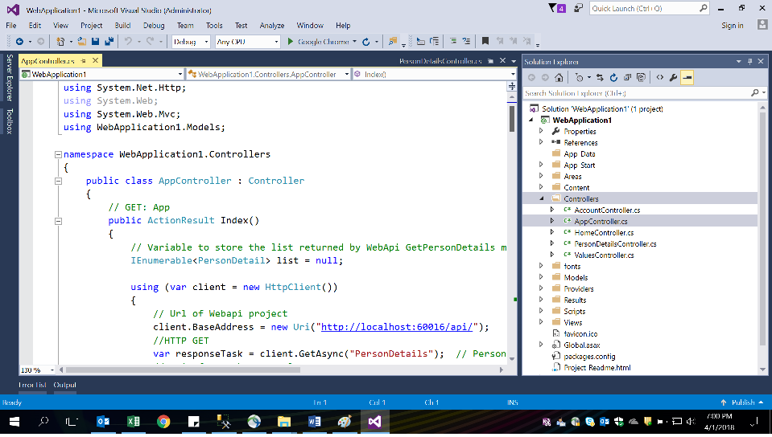

9. Implement Index, Create, Edit, Details and Delete methods

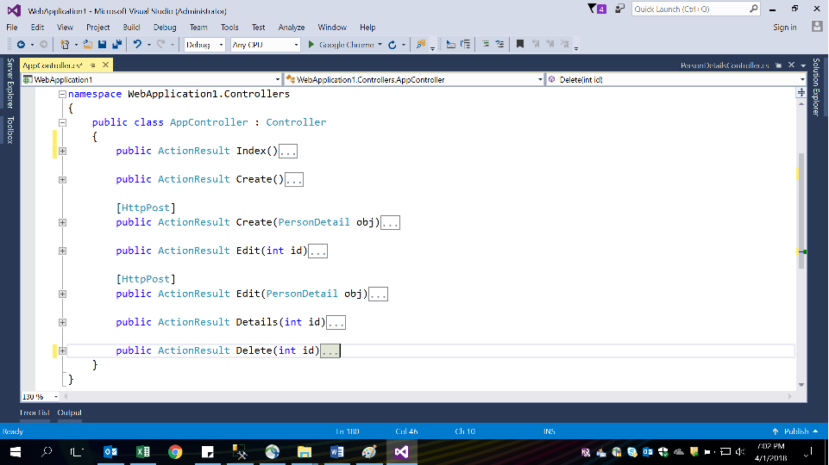

10. From App_Start folder open RouteConfig.cs file and change the route settings.

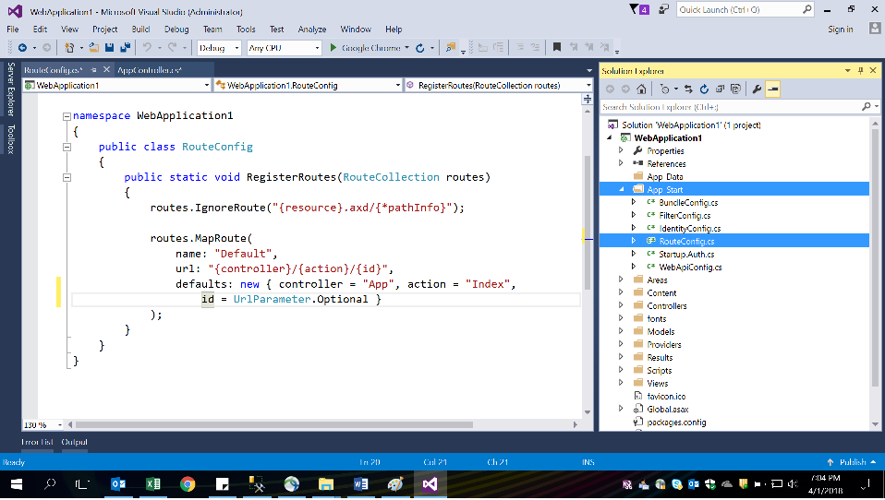

11. Run the application and Test it. Happy Coding.